STA414 assignment 3

Yubo Wang 1002138377



Code:

import numpy as np  
from scipy.stats import norm  
import matplotlib.pyplot as plt  
from numpy import sin, sqrt, exp, pi  
  
def d0(x):  
 return (1 - (sin(5 * x)) ** 2 / (25 * (sin(x) ** 2))) / sqrt(32 * pi) * exp(-x ** 2 / 32)  
  
def d1(x):  
 return (sin(5 * x)) ** 2 / (25 * (sin(x) ** 2)) / sqrt(32 * pi) * exp(-x ** 2 / 32)  
  
def d2(x):  
 return (sin(5 * x))** 2 / (25 * (sin(x) ** 2))  
  
  
def q1a():  
 x = np.linspace(-20, 20, 10000)  
 y = (1 - sin(5 * x) ** 2 / (25 * sin(x) ** 2 )) / sqrt(32 * pi) * exp(-x**2 / 32)  
 fig = plt.figure()  
 plt.scatter(x, y, s=1)  
 plt.show()  
 estimation = np.sum(y)  
 return estimation * 40 / 10000  
  
  
def q1b():  
 accept = []  
 count = 0  
 total = 0  
 while count <= 10000:  
 s = np.random.uniform(0, 1)  
 t = np.random.uniform(-20, 20)  
 y = (sin(5*t)**2) / (25 * sin(t) ** 2) / sqrt(32 * pi) * exp(-t**2/32)  
 if s <= y:  
 accept.append(t)  
 count += 1  
 total += 1  
 plt.hist(accept, 100)  
 plt.show()  
 return count / total  
  
  
def q1c():  
 w = np.random.normal(0, scale=4, size=1000)  
 denom = 0  
 for i in range(1000):  
 x = w[i]  
 y1 = d0(x)  
 denom += y1 / norm.pdf(x, 0, scale=4)  
 result = 0  
 for i in range(1000):  
 x = w[i]  
 result += (1-d2(x))*d0(x) / norm.pdf(x, 0, scale=4) / denom  
 return result  
  
  
def density(theta):  
 px = norm.pdf(1.7, loc=theta, scale=4)  
 pg = (np.sin(5 * (1.7 - theta)) ** 2) / (25 * sin(1.7 - theta) ** 2)  
 return px*pg/((10*pi)*(1+(theta/10)**2))  
  
  
def q1d():  
 theta = np.linspace(-20, 20, 10000)  
 d = density(theta)  
 plt.plot(theta, d)  
 plt.show()

def metropolis(x, iter):  
 lst = []  
 for i in range(iter):  
 u = np.random.normal(x, scale=4)  
 accept = min(1, density(u)/density(x))  
 r = np.random.uniform(0, 1)  
 if r <= accept:  
 x = u  
 lst.append(x)  
 return lst  
  
def q1e():  
 lst = metropolis(0, 10000)  
 plt.hist(lst, 100)  
 plt.show()  
  
def q1f():  
 lst = metropolis(0, 10000)  
 count = 0  
 for i in lst:  
 if -3 < i < 3:  
 count += 1  
 print(count / 10000)  
  
if __name__ == '__main__':  
 print(q1a())  
 print(q1b())  
 print(q1c())  
 q1d()  
 q1e()  
 q1f()

1. 0.799919471407323

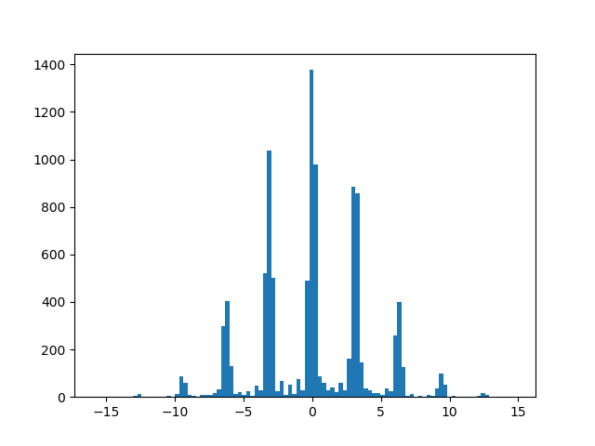

Accepted rate: 0.00499826327718346

1. 0.9253319948922147

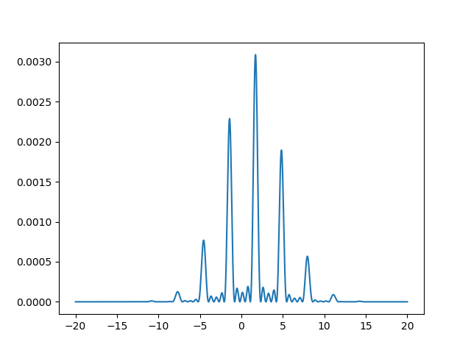



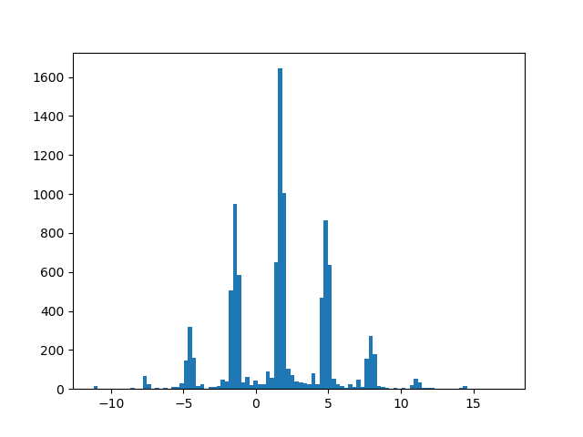





0.6212



First apply the log derivation, then exchange the order of differentiation and integration.



$E_{p\left(x;θ\right)}\left[∇_{θ}\log{p\left(x;θ\right)}\right]=E_{p\left(x;θ\right)}\left[\frac{∇_{θ}p\left(x;θ\right)}{p\left(x;θ\right)}\right]$

$=\int{p\left(x;θ\right)\frac{∇_{θ}p\left(x;θ\right)}{p\left(x;θ\right)}dx}$

$=∇_{θ}\int{p\left(x;θ\right)dx}=∇_{θ}1=0$

$E_{p\left(b | θ\right)}\left[f\left(b\right)\frac{∂}{∂θ}\log{p(b|θ)}\right]=\int{p\left(b | θ\right)}\frac{∂}{∂θ}\log{p\left(b | θ\right)}f\left(b\right)db$

$=\int{\frac{p\left(b | θ\right)}{p\left(b | θ\right)}}\frac{∂}{∂θ}p\left(b | θ\right)f\left(b\right)db$

$=\frac{∂}{∂θ}p\left(b | θ\right)f\left(b\right)db$

$=\frac{∂}{∂θ}E_{p\left(b | θ\right)}\left[f\left(b\right)\right]$

Therefore, the reinforce is unbiased.



$E_{p\left(b | θ\right)}\left[\left[f\left(b\right)-c\right]\frac{∂}{∂θ}\log{p\left(b | θ\right)}\right]=E_{p\left(b | θ\right)}\left[f\left(b\right)\frac{∂}{∂θ}\log{p\left(b | θ\right)}-c\frac{∂}{∂θ}\log{p\left(b | θ\right)}\right]$

$=E_{p\left(b | θ\right)}\left[f\left(b\right)\frac{∂}{∂θ}\log{p\left(b | θ\right)}\right]-cE_{p\left(b | θ\right)}\left[\frac{∂}{∂θ}\log{p\left(b | θ\right)}\right]$

$=\frac{∂}{∂θ}E_{p\left(b | θ\right)}\left[f\left(b\right)\right]-0$ from part a and part b

$=\frac{∂}{∂θ}E_{p\left(b | θ\right)}\left[f\left(b\right)\right]$

Therefore, the reinforce with a fixed baseline is unbiased.



Let $c\left(b\right)=f\left(b\right)$

$E_{p\left(b | θ\right)}\left[\left[f\left(b\right)-c(b)\right]\frac{∂}{∂θ}\log{p\left(b | θ\right)}\right]=E_{p\left(b | θ\right)}\left[0*\frac{∂}{∂θ}\log{p\left(b | θ\right)}\right]$

$=0≠\frac{∂}{∂θ}E_{p\left(b | θ\right)}\left[f\left(b\right)\right]$

Therefore, the reinforce is biased.







$Var\left({\hat{L}}_{MC}\right)=Var\left(\sum_{d=1}^{D}{x_{d}}\right)$

$since x_{i} \sim iid N(θ_{i}, 1)$

$Var\left(\sum_{d=1}^{D}{x_{d}}\right)=\sum_{d=1}^{D}{Var\left(x_{d}\right)}=\sum_{d=1}^{D}{1}=D$

$x_{d}\sim p\left(x_{d} | θ_{d}\right)=\frac{1}{2π}\exp\left(-\frac{{\left(x_{d}-θ_{d}\right)}^{2}}{2}\right)$

$\log{p(x_{d}|θ_{d})}=-\frac{{\left(x_{d}-θ_{d}\right)}^{2}}{2}-\log{(2π)}$

$\frac{∂}{∂π}\log{p(x_{d}|θ_{d})}=(x_{d}-θ_{d})$

$f\left(x\right)-c\left(θ\right)=\sum_{d=1}^{D}{\left(x_{d}-θ_{d}\right)}$

${\hat{g_{i}}}^{SF}\left(f\right)=\sum_{d=1}^{D}{(x_{d}-θ_{d})(x_{i}-θ_{i})}$ where $i∈\{1, …, D\}$

$x_{d}-θ_{d}=ε_{d}$ since $x_{d} \sim N\left(θd, 1\right), ε_{d} \sim N(0, 1)$



${\hat{g_{i}}}^{SF}\left(f\right)=ε_{d}ε_{i}$

${\hat{g}}^{SF}=({\hat{g_{1}}}^{SF}\left(f\right),{\hat{g_{2}}}^{SF}\left(f\right), …,{\hat{g_{D}}}^{SF}\left(f\right))$

$Var\left({\hat{g_{1}}}^{SF}\left(f\right)\right)=Var\left(ε_{1}\sum_{d=1}^{D}{ε_{d}}\right)=Var\left(ε_{1}*ε_{1}+ε_{1}\sum_{d=2}^{D}{ε_{d}}\right)=Var\left(ε_{1}^{2}+ε_{1}\sum_{d=2}^{D}{ε_{d}}\right)$

$=E\left({\left(ε_{1}^{2}+ε_{1}\sum_{d=2}^{D}{ε_{d}}\right)}^{2}\right)-E{\left(ε_{1}^{2}+ε_{1}\sum_{d=2}^{D}{ε_{d}}\right)}^{2}$

$E\left({\left(ε_{1}^{2}+ε_{1}\sum_{d=2}^{D}{ε_{d}}\right)}^{2}\right)=E\left(ε_{1}^{4}+2ε_{1}^{3}\sum_{d=2}^{D}{ε_{d}}+ε_{1}^{2}{\left(\sum_{d=2}^{D}{ε_{d}}\right)}^{2} \right)$

$=E\left(ε_{1}^{4}\right)+2E\left(ε_{1}^{3}\sum_{d=2}^{D}{ε_{d}}\right)+E\left(ε_{1}^{2}{\left(\sum_{d=2}^{D}{ε_{d}}\right)}^{2}\right)$

# since $ε_{d} \sim iid N\left(0,1\right), E\left(ε_{i}ε_{j}\right)=E\left(ε_{i}\right)E\left(ε_{j}\right) for all i≠j$,

$=E\left(ε_{1}^{4}\right)+2E\left(ε_{1}^{3}\right)E\left(\sum_{d=2}^{D}{ε_{d}}\right)+E\left(ε_{1}^{2}\right)+E\left({\left(\sum_{d=2}^{D}{ε_{d}}\right)}^{2}\right)$

# based on hint, $E\left[ε_{i}^{4}\right]=3, E\left[ε_{i}^{3}\right]=0, E\left[ε_{i}^{2}\right]=Var\left(ε_{i}\right)+E{\left(ε_{i}\right)}^{2}=1, E\left(ε_{i}\right)=0$ for $i∈\{1, …, D\}$



$=3+2*0*0+1*\sum_{d=2}^{D}{E\left(ε_{d}^{2}\right)}$

$=2+D$

$E{\left(ε_{1}^{2}+ε_{1}\sum_{d=2}^{D}{ε_{d}}\right)}^{2}={\left(E\left(ε_{1}^{2}\right)+E\left(ε_{1}\right)E\left(\sum_{d=2}^{D}{ε_{d}}\right)\right)}^{2}={\left(1+0\right)}^{2}=1$

$Var\left({\hat{g_{1}}}^{SF}\left(f\right)\right)=2+D-1=1+D$

${\hat{g}}^{REPARAM}\left(f\right)=\frac{∂f}{∂x} \frac{∂x}{∂θ}$

$f=\sum_{d=1}^{D}{x_{d}}$

$\frac{∂f}{∂x_{i}}=1$

$x_{i}=θ_{i}+ε_{i}$

$\frac{∂x_{i}}{∂θ_{i}}=1$

${\hat{g_{i}}}^{REPARAM}\left(f\right)=1*1=1$

${\hat{g}}^{REPARAM}=(1,…,1)$*,* size (1xD)

$Var\left({\hat{g_{i}}}^{REPARAM}\right)=Var\left(1\right)=0$